Kazoo - Harmonica - Flute

Subject:  Related Subjects: | Grade Level(s): k,2,6,8  Length of Lesson: | Type: Inquiry / Design / Project  Keywords: Pitch, wavelength, frequency, Bernoulli

Lesson Overview
Use this section to describe at a high level what the lesson is. Should be no more than 3-4 lines.

Lesson Focus
What is the central question or phenomenon being investigated? What problem are they trying to solve?

Lesson Objective(s) | - Students will create a kazoo to demonstrate vibration and sound  - Students will create a harmonica to demonstrate vibration and sound  - Students will create a flute to demonstrate vibration and sound

Lesson Timing

5 minutes | Introduce the Lesson
30 minutes | ...

Materials | - –Straw  - –Scissors  - –PVC pipe  - –Saw  - –Latex (balloon or gloves)  - –Rubber band  - –Electrical Tape  - –Film canister  - –Sandpaper  - –Glue  - –Clothes pin  - –Flat rubber band
Instructor Prep | - Step 1
Related Resources | - List related lessons/ppts etc available from USC or outside, trusted orgs

Lesson Plan

Introduction
The basis of sound is vibration. Vibration causes longitudinal waves in the air. An example of a longitudinal wave is like pulling one end of a slinky. A disturbance is typically created within the slinky by the back and forth movement of the first coil of the slinky. The first coil becomes disturbed and begins to push or pull on the second coil; this push or pull on the second coil will displace the second coil from its equilibrium position. As the second coil becomes displaced, it begins to push or pull on the third coil; and so on in consecutive fashion with each individual particle acting to displace the adjacent particle; the disturbance eventually travels through the slinky. As the disturbance moves from coil to coil, the energy, which was originally introduced into, the first coil is transported along the medium from one location to another.

This longitudinal wave moves through matter (gas, liquid or solid) in the same way. In air, the vibration reaches our ear and travels down the ear canal and strikes the tympanic membrane causing it to vibrate. These vibrations are then transferred to the chain of bones in the middle ear. Muscles and ligaments hold this fragile chain of bones in place and allow them to vibrate back and forth with sounds. The first bone in the chain is called the Malleus (hammer), the second is called the Incus (anvil), and the last bone is called the Stapes (stirrup). The sound vibrations cause the Stapes to move back and forth. This motion is thus transferred to the inner ear.
The cochlea or hearing portion of the inner ear is shaped like a spiral seashell or a snail. Its purpose is to take the vibrations of the middle ear bones and transform them into nerve impulses that will then go to the brain. It accomplishes this by allowing the middle ear bone called the stapes to vibrate back and forth through a small opening in the cochlea. This opening is connected to fluid filled canals. The vibration of the stapes causes pressure waves in the fluid. These waves travel down the canal, bending small hair type cells. The frequency (pitch) and intensity (volume) of the sound determine which hair cells are bent. When the hair cells bend, they release a nerve impulse to the brain. We perceive these nerve impulses as sounds.

Procedure
Components and Parts

- – Tear strip of paper for each student. (1” by 8 ½”)
- – Cut 12” piece of PVC pipe

Construction

- –Hold paper below lower lip and let hang
- –Have students blow over paper and observe what happens
Kazoo

- –Cut the end of straw 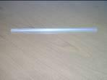in a “V” shape.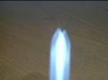

- –Flatten “V” end of straw.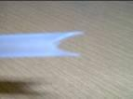 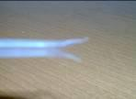
- –Insert “V” end in mouth and blow.

- –Take a clothes pin apart.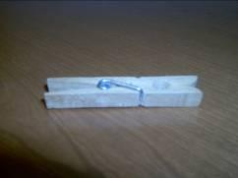 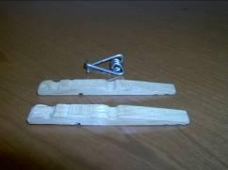
- –Wrap electrical tape around both ends of both pieces of clothes pin.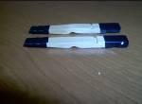
- –Wrap flat rubber band around one piece.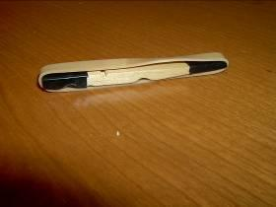
- –Pull rubber band taut and hold.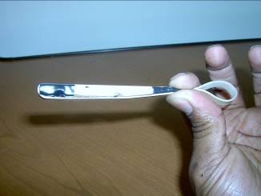
- –Place flat side of second piece against the rubber band on the flat side of the first piece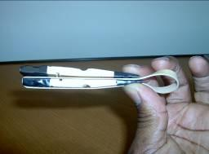
- –Wrap rubber band around second piece holding it in place against first piece.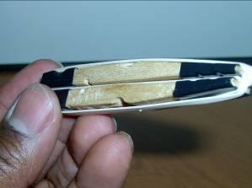
- –Place your mouth on the side and blow. This is your harmonica.

Flute

- –Place film canister of one end. 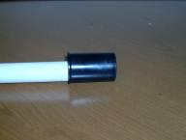
- –Carefully tape top of film canister to sides of PVC while keeping film canister bottom flat on top of PVC. Do not let tape take up more than ½” of film canister.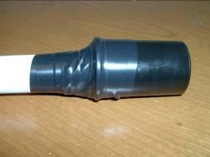
- –Add tape until no air escapes when you blow into other end of pipe.
- –Carefully cut 1/8” from bottom of film canister and PVC.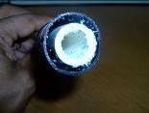
- –Sand new opening to make sure it is flat.
- –Cut 4” square of latex.
- –Cover film canister end of PVC with latex.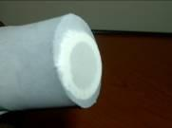
- –Use rubber band to hold latex in place.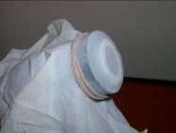
- –Make small opening in film canister (but not PVC) near top end of canister near tape (this is your mouthpiece).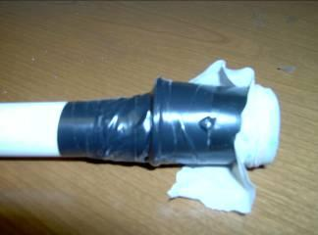
- –Pull latex tight under rubber band.
- –Trim latex away from opening
- –Blow
- –You may need to push pipe up and pull canister down to increase tension in latex.

Troubleshooting

- For Kazoo - make sure “v-shaped” end of straw is flat
- For Kazoo – make sure student’s lips are on straw about 1” beyond v-shaped end

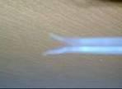

- For harmonica make sure rubber band is flat between two pieces
- For Flute - You may need to push pipe up and pull canister down to increase tension in latex.

Wrap-up
- Students will change length of kazoo and flute and notice different sounds.
- Students can make holes in kazoo or drill holes in flute to make different sounds.
- Students can glue a straw over the hole in the mouth piece to make a saxophone (must make sure hole isn’t blocked by glue)

Lesson Background for Teachers

Suggested Real-World STEM Connections
- List possible related Role Models in STEM (with details and links to more reading). Give suggestions for examples of scientists/engineers who are from underrepresented groups in STEM in related careers.
- List related real-world engineering problems and examples

Lesson Variations and Options
Include descriptions of alternative methods or ways to present things.

Explanation

Kazoo
Students will cut the end of a straw into the shape of a “V” and then blow. Bernoulli’s theory says that air passing a tube will cause the air in the center to flow faster than the air on the sides. This causes a decrease in pressure in the center along the length of the tube. When you blow in the straw, there is a pressure drop. The pressure from the outside (in your mouth) causes the ends to collapse. When the ends collapse no further air flows inside. The natural spring of the plastic returns the ends to their natural open state. Air flows again and the process repeats. This causes the ends of the straw to vibrate. This vibration is carried down the length of the straw creating a sound wave.

Harmonica
Students stretch a rubber band between two flat surfaces from a clothes pin. Just as in the kazoo, as the air blows through the space, the rubber band moves up and down causing vibration and sound.

Flute/Saxophone
Students attach a film canister to the end of a PVC pipe and cut off the end.

Side view

Top view

The now open end is covered with latex from a balloon or latex glove and held in place with a rubber band. A hole is made in the side of the canister as mouthpiece. When the student blows in the hole, air is forced between the latex and the end of PVC. When the force of the air is larger than the elasticity of the latex, the latex is stretch and the air goes through. The elasticity of the stretch latex combined with the pressure drop caused by the airflow forces the gap created to close. Then the whole process repeats itself causing a vibration. The vibration is carried down the length of the PVC pipe.

In the kazoo and flute, the longer the tube, the lower the pitch, and the shorter the tube the higher the pitch. The longer tube creates a longer sound wave. The longer the wavelength, the lower the frequency of vibration and the lower the sound, and the shorter the wavelength, the higher the frequency of vibration and the higher the sound.

Key Concepts and Vocabulary
- Primary – Vibration causes sound
- Secondary – Air flow causes objects to move and create vibration
- Tertiary – Size of object changes sound

Safety Notes
- Students with allergies from latex should not participate in this activity.
- Students must exercise caution in using scissors and saws.
- Clean all pieces before you place you mouth on them.

